**VIRTUAL CSOs SENSITIZATION WORKSHOP ON THE STATUS OF IMPLEMENTATION OF SDG 7 IN KENYA**

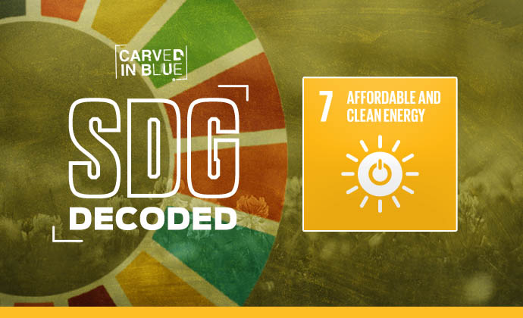

**Held on 1st October 2020**

**Supported by WWF-KENYA**

**Prepared by: Vincent Ondieki**

**Governance Working Group-SEAF-KENYA**

***www.seafkenya.org****;* ***info@seafkenya.org***

**Held on 1st October 2020**

**Supported by WWF-KENYA**

**Prepared by: Vincent Ondieki**

**Governance Working Group-SEAF-KENYA**

**www.seafkenya.org**; **info@seafkenya.org**

**Table of Contents**

ACRONYMS AND ABBREVIATIONS 2

1. Background 3

2. Objective of the Meeting 3

3. Welcoming Remarks 4

4. A Synopsis of SDG7 processes in Kenya 5

5. The 2030 Agenda for Sustainable Development Goals (SDGs) SDG 7: Affordable and Clean Energy 7

6. Major challenges in the implementation of SDG 7 9

7. Panel discussion 10

8. Closing Remarks 11

9. Way forward and Wrap up 12

Annex 1 13

Annex 2 14

Annex 3 15

# ACRONYMS AND ABBREVIATIONS

AA Agenda Action

AGM Annual General Meeting

CSOs Civil Society Organizations

IP Investment Prospectus

MoEP Ministry of Energy and Petroleum

RAGA Rapid Assessment and Gap Analysis

NDC Nationally Determined Contribution

RE Renewable Energy

SEAF-K Sustainable Energy Access Forum Kenya

SE4ALL Sustainable Energy for All

SDG Sustainable Development Goal

VNRs Voluntary National Review

# Background

Energy deeply influences people’s lives and is an engine for social development and economic growth. Over the centuries, energy has helped transform societies and has underpinned human development. Energy contributes to fulfilling the most basic human needs, including nutrition, warmth, and light. Furthermore, there is ample evidence that access to reliable, efficient, affordable, and safe energy carriers can directly affect productivity, income, and health, and can enhance gender equity, education, and access to other infrastructure services. However, energy use patterns, in terms of both quality and quantity, are highly inequitably distributed on all sides of the development divide – North and South, rich and poor, men and women, rural and urban. This inequity in energy access and use compromises human welfare and has adverse impacts on the environment.

The wealth and development status of a nation and its inhabitants is closely correlated to the type and extent of access to energy. The more ready usable energy and the more efficient energy-converting technologies are available, the better are the conditions for the development of individuals, households, communities, the society, and its economy. Thus, improving access to energy is a continuous challenge for governments and development organizations.

Identifying the importance of access to sustainable energy for future development, Kenya Enacted the Energy Act 2019 to consolidate the laws relating to energy and provide for National and County Government functions in relation to energy. The Act seeks to, among others, provide for the establishment of energy sector entities; promote renewable energy, exploration, recovery, and commercial utilization of geothermal energy; regulation of midstream and downstream petroleum and coal activities. Besides, Kenya being a member state of the United Nations has been instrumental in advocating for the implementation of Sustainable Development Goals. SDG 7 serves as one of the most critical areas that cut across all other goals, it aims to ensure access to affordable, reliable, sustainable, and modern energy.

To make this a reality in Kenya it requires stronger voices that can push for sustainable energy solutions. It is against this backdrop that the Sustainable Energy Access Forum Kenya (SEAF-K) through the Governance Working Group organized a virtual Civil Society (CSOs) sensitization workshop to comprehend the status of SDG 7 in Kenya and take note of entry points/opportunities and synergies that civil societies could employ in promoting the implementation of SDG 7. The virtual dialogue was held on 1st October 2020 hosting participants from civil societies, county government, and a representative from SDGs forum Kenya and renewable energy directorate, Ministry of Energy who served as facilitators of the day. A total of 27 participants attended the meeting 16 Male 11 Female

# Objective of the Meeting

To commence the meeting, Juliet Makoha the Chair of the Governance thematic group welcomed the participants and appreciated their commitment to the energy access discourse. She then reminded the participants that the Governance working group was established to spearhead SEAF-K’s engagement in national and county policy dialogue platforms and processes to influence the development and implementation of key policy and legal frameworks that create an enabling environment for sustainable energy management and in particular promote the energy access agenda. She gave the overall objective of the workshop as to enhance the capacity of Civil Society Organizations in their policy advocacy work. The specific objectives were:

* Increased understanding of the Energy Act and SDG7 and target areas in general and renewable energy, including the cross-sectorial linkages.
* A better understanding of policy, strategy, and practice towards developing integrated sustainable energy programmes.
* Improved understanding of the major challenges that stakeholders face in the implementation of the Energy Act and the efforts towards SDG7.
* Strong professional networking to promote active debate on cross-sectoral integration and the sustainable energy nexus as related to the development of indicators, monitoring, and evaluation mechanism.

# Welcoming Remarks

**Irene Mwaura- Project Officer, Energy, and Climate Change WWF-K**

Ms. Mwaura began by appreciating the participants for their resilience and consistency in pushing for sustainable energy adoption in Kenya. She added that the overwhelming attendance was a positive gesture that reflected commitment towards energy accesses. In her remarks, she noted that the meeting came at an opportune moment when globally people are struggling as a result of the COVID-19 pandemic, and energy affordability was becoming a challenge. On SDG 7 topic, she noted that it has three main goals and two subset goals that focused on renewable energy access, doubling the global rate of improvement on renewable energy efficiency, and ensuring the contribution of reliable, affordable, and modern energy services. In reference, to the SDG 7 tracking reports shared in May 2019, she noted that globally there was little progress in achieving SDG7. She highlighted that currently, over 780million people do not have access to electricity and over 2.8 billion people do not have accesses to clean cooking services. Ms. Irene lamented that Kenya is part and parcel of the global statistics and to improve the situation, she challenged development partners and stakeholders in energy sectors to ensure Kenya’s figures within the global statistics reduce.

Ms. Irene noted that already WWF-K was implementing several initiatives towards addressing energy access, renewable energy affordability, and energy efficiency. On energy efficiency, for instance, she recounted that they were working with a tea factory to pilot the use of solar parabolic trough systems to minimize the use of firewood within the tea factory. She hoped that it can be adopted and replicated by other industries that are reliant on firewood or fuel. In addition, she informed participants that WWF-K was working with farmers and fisherfolks to promote the adoption of off-grid cooling solutions at affordable rates as well as promoting the use of renewable energy solar water pumps in the agriculture sector to enhance food security. Finally, she mentioned that they were promoting the adoption of solar lighting home systems and improved cooking solutions. She concluded by stating that all had a role to play in advancing energy access and wished all participants a fruitful discussion and deliberation.

**John Kioli - Chairman, KCCWG and member of National Climate Change Council**

In his remarks, he thanked participants for creating time to attend the virtual dialogue on SDG 7. He also extended his gratitude to the governance thematic group, WWF-K for financially supporting the energy access engagements and the facilitators for sharing knowledge on energy status both globally and in Kenya. He noted that as sustainable energy for all forum in Kenya, they were concern about issues of affordability, reliability, sustainability, and accesses to modern energy for all as they are the key ingredients for SDG7. Mr. Kioli pointed out that from 2012 1.1 billion people had no access to electricity and this immensely affected many development sectors such as small-scale traders, industries, hospitals, schools, and other critical enterprises. In conclusion, he mentioned that issues of energy accesses are key and more especially to people who cannot access affordable energy. He also emphasized on the need to think about energy efficiency alongside renewable energy as a starting point. Having made these sentiments, he officially declared the meeting opened and welcomed participants to an engaging discussion.

# A Synopsis of SDG7 processes in Kenya

**Paul Mbuthi-Deputy Director, Renewable energy Directorate, Ministry of Energy**

To kick off the presentation, Mr, Mbuthi began by stating the Ministry of Energy mission and vision as follows;

* Mission: to facilitate the provision of: clean, sustainable, affordable, competitive, and secure energy for national development while protecting the environment.
* Vision: affordable, competitive quality energy for all Kenyans

He went further and gave contextual information on sustainable energy for all where he mentioned that the UN Secretary-General Ban Ki-moon launched the Sustainable Energy for All Initiative (SE4All) in September 2011 to achieve three inter-related goals by 2030;

* Ensuring universal access to modern energy services;
* Doubling the global rate of improvement in energy efficiency;
* Doubling the share of renewable energy in the global energy mix.

In his presentation he further stated that the SE4All Initiative requires countries to set quantitative objectives for each of the three goals and due to this;

* Kenya opted to be part of the SE4All Initiative in 2012 and the MoEP initiated the development of the action agenda and investment prospectus in 2014 after completion of stock-taking and gap analysis in June 2013

**Actions and timelines for Kenya’s SE4ALL Programme**

In providing further information with regards to the SE4ALL programme, Mr. Mbuthi highlighted that Kenya’s SE4All Action Agenda (AA) and the Investment Prospectus (IP) were developed through a highly consultative process and quite a number of organizations were involved. The EU BiZClim Facility funded the development of the first draft of the SE4All Action Agenda (AA) and Investment Prospectus (IP).

HCL Consultants developed the initial draft of the AA/IP. After conducting extensive stakeholder consultations and presented the first draft AA and IP to stakeholders for comments.

Based on the Stock-taking and Gap Analysis Report and discussions with key stakeholders, the AA includes the following priority actions:

* Improving the policy and regulation of the energy sector:
* Human and institutional capacity development:
* Increase access to electricity
* Increase access to modern cooking solutions

AA/IP mandated MoEP to work across government agencies and with stakeholders to:

* Develop and implement a National Energy Efficiency Programme to assess opportunities for energy efficiency in multiple sectors.
* Implement and enforce standards for electric appliances. To increase their efficiency and impact, a national awareness campaign targeting consumers and distributors will be carried out.
* MoE to lead in awareness creation on the use of clean cookstoves and fuels as a health benefit to prevent deaths and sickness from indoor air pollution.
* MoE to promote institutional capacity development and create awareness of energy efficiency. Develop and implement cookstoves dissemination projects.
* Define and scale-up certification processes for residential and commercial cookstoves

**SEforALL Implementation Phases**

* Phase I (2018 – 2022): SE4All becomes the key energy sector reference for the MTP 3 planning and implementation process. In this context, the AA will be assessed by its implementation progress and additional interventions and Investment Prospectuses (IPs) will be incorporated as needed.
* Phase II (2023 – 2027): The AA will be re-assessed by its progress and additional interventions and IPs will be incorporated as needed, in the preparation of MTP 4.
* Phase III (2027 – 2030): The AA will be re-assessed by its progress and additional interventions and IPs will be incorporated as needed, in the preparation of MTP 5.

**Follow on Activities on Implementation of SEforALL AA/IP Kenya**

* Clean Cooking Forum: Kenya in collaboration with Clean Cooking Alliance hosted a clean cooking Forum in November 2019 in Nairobi. The Forum came up with a set of recommendations to prioritize clean cooking in all countries.
* Launch of Kenya Household Sector Study during the Forum
* Clean Cooking side event July 2020
* This year Kenya joined High Coalition for Health and Energy Platform of Action and the cabinet secretary is a member of the coalition.
* Kenya serves in Technical Advisory Group (TAG) for SDG 7 (every year Kenya participates in preparing of energy policy briefs of SDG7)
* Kenya National Energy Efficiency & Conservation Strategy 2020 (Kenya supports Energy Audits)
* Bioenergy Strategy 2020 (it focuses on energy technologies)

In conclusion, Mr. Mbuthi notified the participants that the global target of how many people are without access to clean cooking is changing because of the metrics/measurements. It has been presumed that 2.8 billion people lack access to clean energy for cooking and this number has been revised upwards. A report shared by the World Bank recently indicates that 4billion people are without access meaning the challenge is huge hence the need to raise ambitions by involving all stakeholders.

# The 2030 Agenda for Sustainable Development Goals (SDGs) SDG 7: Affordable and Clean Energy

**Florence Syevuo-Coordinator-SDGs forum Kenya**

In enhancing the understanding of participants on the SDG 7 Implementation process, Ms. Syevuo began by introducing the SDG Kenya forum technical group as shown below;

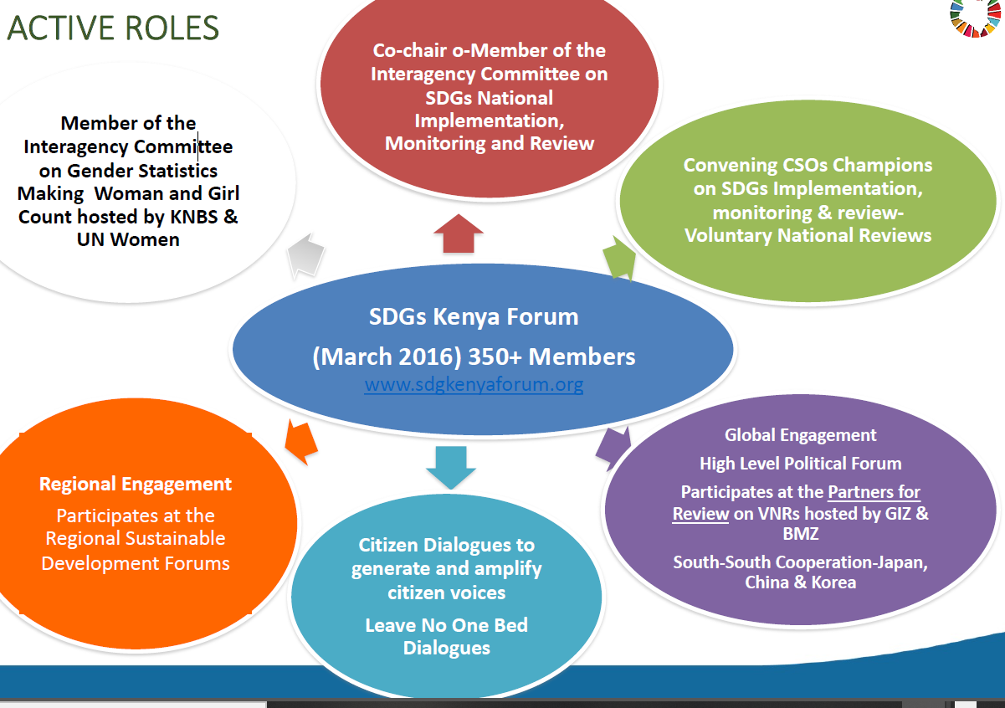She also elaborated why SDG7 is important stating that;

* Sustainable Development Goal (SDG) 7 focuses on a concerted global effort to ensure access to affordable, reliable, sustainable, and modern energy for all. SDG 7 has 5 Targets and 6 Indicators.
* Access to clean, modern, sustainable energy is critical for improving the health and livelihoods of billions of people around the world.
* The UN explains: "Energy is central to nearly every major challenge and opportunity the world faces today. Be it for job security, climate change, food production, or increasing incomes, access to energy for all is essential.

On the voluntary national review, she pointed out on the following;

The 2030 Agenda defines and has a functional follow up and review process. The annual Voluntary National Reviews (VNRs) process comprise the mechanisms through which progress against the SDGs is being measured at both national and international level. In 2015, Member states committed to a robust, voluntary, effective, participatory, transparent, and integrated follow-up and review framework. These are meant to;

* Help countries to **track and assess** progress in attaining the 2030 agenda (**to** **ensure that no one is left behind**);
* Guide **policy, planning, budgeting, and implementation**;
* Help countries **develop a better understanding** of the problems and the shortcomings encountered;
* Develop appropriate policies, structures, and processes to achieve sustainable development.

Regarding Kenya’s process on the voluntary national review, Ms. Syevuo noted that

* Kenya has so far engaged in the 2017 and 2020 VNR global processes
* In 2019 Kenya produced its first Biennial report
* CSOs have actively engaged the three processes producing
* CSOs VNR Submissions based on Goal Groups

She further provided links to SDGs progress reports annexed in this report.

**Lessons Learned**

The following lessons were gathered from the SDGs Forum which Civil Societies can take note in their advocacy and governance work;

* Need to continuously Build Capacity and SDGs Target and Indicator alignment for all SDG7 stakeholders on VNR process
* Invest in research and encourage evidence-based reporting (Generating Data and statistics).
* Create awareness and supporting citizen to tell their stories on SDG 7 at grassroots level.
* Improve collaboration and synergy among stakeholders e.g. African Regional
* Forum on Sustainable Development, Global SDG 7 Conference, National Level Processes lead by the Ministry of Energy

# Major challenges in the implementation of SDG 7

**Jacqueline Kimeu-International Coordinator, ACCESS COALITION**

Mrs. Kimeu began her presentation by sharing an overview of the Access coalition where he mentioned that it is a global coalition of over 70 CSOs working at the local, national, regional, and international levels.

* **Mission:** to advocate for people living in poverty to have access to safe, reliable, and affordable energy, and for environmentally sustainable and efficient energy systems globally
* **Clarion call: ‘**Strengthening the efforts of CSOs to deliver universal access to Energy’

She also highlighted that the access coalition operated on the following key areas;

* World Bank and AfDB engagement
* SDG 7 implementation
* Knowledge and capacity building- ACCESS Learning Group

In bringing members to speed with the challenges experienced in the implementation of SDG 7 she noted the following gaps;

* Limited understanding among actors of the value of DRE solutions and the other types of approaches in delivering energy access
* Insufficient understanding of the linkages between energy access and wider development goals
* Unclear, timely, and regular engagement of all stakeholders in energy access decision making –SDG 7
* Absence of robust and regular monitoring and evaluation mechanisms with meaningful metrics for energy access
* Processes for implementing the SDGs and the reporting and accountability mechanisms are still being developed- (largely voluntary)
* Lack of CSOs data to inform and track progress on SDG 7 implementation (CSOs are doing a lot but little is reported/documented)
* Insufficient understanding and collaboration with allies working in other development sectors on the role of energy access in enabling progress on other SDGs (Most stakeholders are working in silos)

In her concluding remarks, she noted that CSOs need to take note of the gaps and develop a stronger working relationship while taking advantage of existing networks and enabling environment from the Ministry of Energy. She also emphasized on the need for civil societies to contribute to energy processes at the national, regional, and global level and also localize information coming from the regional and global level. Finally, she challenged partners to join accesses coalition and add value to the SDG 7 processes and implementation at all levels.

The following concerns were noted from the plenary sessions

# Panel discussion

* What is the Ministry of Energy doing to ensure the target of 4 million households accesses improved clean cooking stoves? In meeting the target, the Ministry is implementing different projects in ensuring this is addressed. The ministry is also facilitating private sectors and entrepreneurs to be able to develop market systems and production of the entire supply chain of the stoves. The Ministry has two programmes one on capacity building to the counties to support County energy planning where counties have an opportunity to indicate demands of the improved or clean cooking solutions. The other project is on the Global Climate Fund on professionalizing clean cooking products in the country implemented in Kenya and Senegal through GIZ.
* Is there a global tracking framework for SDG 7 and how can it be localized? Yes, it is available. The framework identifies the indicators of what is to be tracked and it is classified into five tears from 0-5 depending on the number of parameters. The zero represents people without access to clean cooking solutions.
* What actions has the government put in place as far as waste to energy development is concerned as a source of energy and environmental management? The government has a plan to come up with waste to an energy strategy that will provide a proper guide on how to handle the component. However, CSOs and the private sector can venture into this initiative as the government's role is to facilitate and create an enabling environment in implementation.
* Has the SDG forum done any translations to enable people at the grass-root level to comprehend what SDG 7 is and how it can be implemented? Yes, SDGs have been translated into local language and national language Swahili. However, there is still a need to have more translations done in unentered areas as well as the support of materials development with summarized information i.e. infographics. CSOs can therefore take up this challenge and assist in making this possible.
* What plans does the Access coalition have in addressing major challenges/gaps in the implementation of SDG 7? Access has been pushing for the implementation of SDG 7 at the global, regional, and national levels and it is now collaborating with like-minded forums such as SEAF-Kenya to upscale the discussions. It is also trying to rope in CSOs working on Energy issues in Kenya to join and support the process. Access coalition is also championing for SDG 7 activity reporting for easier tracking of the milestones made so far in its implementation.
* Does access have an opportunity for capacity building at the local level? Yes, Knowledge and capacity building is an area that access is key on especially on energy issues and it is collaborating with the Kenya Climate Change Working Group (KCCWG) to ensure the people at the local level are reached.
* Based on the SDG 7 indicators access to energy is still a challenge with barely less than a decade left to 2030. COVID-19 has worsened the situation hence much needs to be done to upscale the process.
* There is a need for combined efforts to raise ambition to address energy access, especially on clean cooking.

# Closing Remarks

**Ms. Irene Mwaura - Project Officer, Energy and Climate Change WWF-K**

In her remarks, she thanked the presenters for the informative information they had shared on SDG 7. She also noted that from the discussion there remains much to be done hence calling for collaboration by all stakeholders. Finally, she emphasized that there is a need to closely work with the Ministry of Energy in the Country as they are taking lead in energy engagements.

**Mr. John Kioli - Chairman, KCCWG and member of National Climate Change Council**

In his closing remarks, he expressed his gratitude to all the presenters for the fruitful and informative discussions. He also thanked the Governance thematic group and WWF-Kenya for organizing and supporting the meeting.

# Way forward and Wrap up

On the next steps, Mr. Ondieki informed the participants that SEAF-Kenya will be holding an annual general meeting (AGM) in the coming weeks, and thereafter the governance thematic group will organize one more meeting to engage further on the energy agenda. He also reported that the thematic group was keen on following up on the discussions from the previous and current sessions to ensure all the action points have been considered. Finally, he assured the participants that all the presentations and reports for the meeting will be shared in a good time for their review and action.

# Annex 1

Links to SDGs Progress Reports

1. To read the 2020 Government of Kenya VNR Report, please click on: <https://bit.ly/2C87Vs5>
2. To read the 2020 Civil Society VNR Report, please click on: https://bit.ly/3fBIrlH
3. To read the 2017 Civil Society VNR Report, please click on: https://sdgkenyaforum.org/content/uploads/documents/b2171f0f31ee20e4.pdf
4. To read the 2019 Civil Society Progress Report, please click on:
5. <https://sdgkenyaforum.org/content/uploads/documents/6c1e1bb60b0902e2.pdf>

# Annex 2



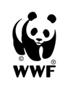**VIRTUAL CSOs SENSITIZATION WORKSHOP ON THE STATUS OF IMPLEMENTATION OF SDG 7 IN KENYA**

**Thursday 1st October, 2020 | 9.30am – 12:00 Noon**

**Agenda**

|  |  |  |
| --- | --- | --- |
| **Time** | **Activity** | **Session Chair** |
| **9:15-9:30am** | Check-in and zoom connection  **Brian Omenyi-Intern, SEAF-K** | Jacob Olonde-**CEO, ECAS** |
| **9:30-9:40am** | Climate setting and Objectives of the meeting  **Juliet Makokha, Convener, Governance Thematic Working Group** |
| **9:40-10:00am** | **Welcome remarks**  **Irene Mwaura**- Project Officer, Energy and Climate Change WWF-K  **John Kioli**- Chairman, KCCWG and member of National Climate Change Council |
| **10:00-10:20am** | A Synopsis of SDG7 processes in Kenya  **Paul Mbuthi- Deputy Director, Renewable energy Directorate Ministry of Energy** |
| **10:20-10:30am** | Plenary |
| **10:30-10:50am** | Entry points, Opportunities and synergies that civil societies could tap into in promoting implementation of SDG7 in Kenya  **Florence Syevuo-Coordinator-SDGs forum Kenya** |
| **10:50-11:10am** | Major challenges in the implementation of SDG 7  **Jacqueline Kimeu-International Coordinator, ACCESS COALITION** |
| **11:10-11:40am** | **Plenary** |
| **11:40-12:00pm** | Next steps, wrap up and close  **Vincent Ondieki-Lifeskills** |

# Annex 3

**SEAF-KENYA GOVERNANCE THEMATIC GROUP PARTICIPANTS**

|  |  |  |  |  |
| --- | --- | --- | --- | --- |
| **Name** | | **Organization** | **Email** | **Phone No** |
| 1. | John Kioli | KCCWG | kiolijohn@gmail.com | 0722722915 |
| 2. | Frank Msafiri | SusWatch Kenya | frankmsafiri46@gmail.com | 0721344707 |
| 3. | Juliet Makokha | SusWatch Kenya | [jmakokha22184@yahoo.com](mailto:jmakokha22184@yahoo.com) | 0724788032 |
| 4. | Jacob Olonde | ECAS | [olondejacob@gmail.com](mailto:olondejacob@gmail.com) | 0728925306 |
| 5. | Vincent Ondieki | Lifeskills Promoters | [vincentndk3@gmail.com](mailto:vincentndk3@gmail.com) | 0723734468 |
| 6. | Justus Munyoki | Inforse | [justusmunyoki40@gmail.com](mailto:justusmunyoki40@gmail.com) | 0725170261 |
| 7. | George Kiritu | RENEWGEN | [kiritukiritu@gmail.com](mailto:kiritukiritu@gmail.com) | 0722392390 |
| 8. | Elizabeth Wanja | KCCWG | [ewanja53@yahoo.com](mailto:ewanja53@yahoo.com) | 728 923695 |
| 9. | Mary Mutemi | Green Africa Foundation | [mumbuamarrie@gmail.com](mailto:mumbuamarrie@gmail.com) | 0721142856 |
| 10. | William Okoyo | KIRDI | [okoyowilliam@gmail.com](mailto:okoyowilliam@gmail.com) | 0721666047 |
| 11. | Daniel Onudi | Ministry of Energy | [onudid@hotmail.com](mailto:onudid@hotmail.com) | 0701147580 |
| 12. | Brian Omenyi | SEAF-K | [omenyibrian@gmail.com](mailto:omenyibrian@gmail.com) | 0701953683 |
| 13. | Michael Khaduyi | YMCA | [mkhaduyu@gmail.com](mailto:mkhaduyu@gmail.com) | 0714615407 |
| 14. | Jacqueline Kimeu | ACCESS | [kimeu.mwende@gmail.com](mailto:kimeu.mwende@gmail.com) | 0720439495 |
| 15. | Hellen Maina |  |  |  |
| 16. | Wycliffe Amakobe | KCCWG | amakobe@kccwg.org | 0728917356 |
| 17. | Siama Muli | GROOTS | smuli@gmail.com | 0728102427 |
| 18. | David Jesse | GREEN DRIVE EA | greendriveea.org@gmail.com | 0782579308 |
| 19. | John Solonka | Wildlife Foundation | [sinkeet1@yahoo.com](mailto:sinkeet1@yahoo.com) | 0720754269 |
| 20. | Daniel Kamau | SAN TRANSFER | dan@santransfer.org | 0735619230 |
| 21 | Irene Musundi | RECONCILE | musundi-@reconcile@org | 0704950484 |
| 22 | Irene Mwaura | WWF-K | imwaura@wwfkenya.org | 0798499245 |
| 23 | Paul Mbuthi | MOE | pmbuthi@gmail.com |  |
| 24 | Florence Syevuo | SDG-Kenya | florence@sdgkenyaforum.org |  |
| 25 | Mariam Karanja | CCAK | karanjamariam@gmail.com | 0727875766 |
| 26 | Khanali Joy |  | khanalijoy78@gmail.com | 0795378012 |
| 27 | Agnes Wangari |  | wangari.2016@yahoo.com | 0723861976 |